Project Python

Aim: Creating a web application which accommodates movie data.

# Entity Relation Diagram

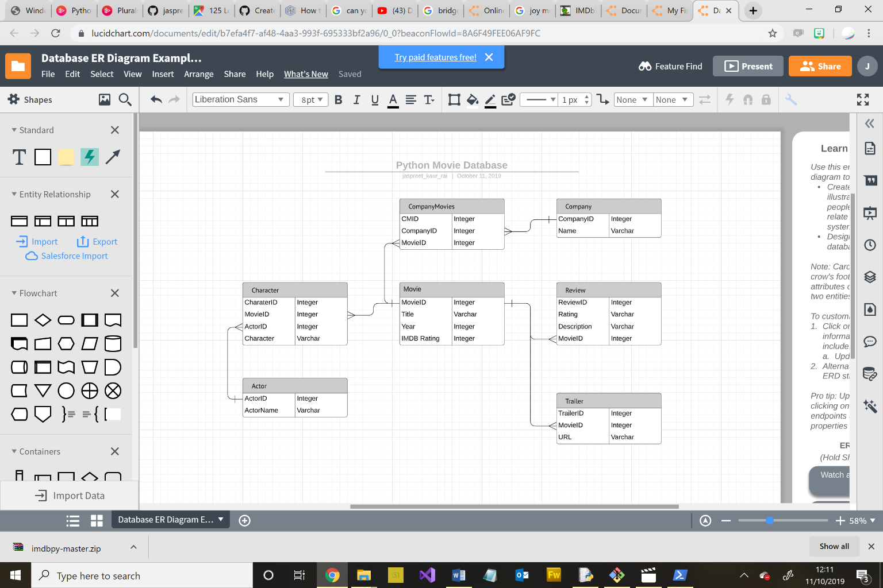

# User Story

As a User I want to be able search for data with predictive text so the system can give me options while I type.

As a User I want to be able to select data so I can know more about its details.

As a User I want to see reviews so I can know which movies to watch

As a User I want to search by movie, actor, character or company so I can receive data accordingly

As a User I want to watch the trailer for a movie so I can see if I want to watch the movie

As an Admin I want to add all movie data such as Movie metadata, IMDB rating, reviews, trailer links so I can keep the users up to date with movies

As an Admin I want to edit movie data so I can add more reviews to keep users informed

# Timeline

Week 1

* Finish Log code
* User Story
* ERD Diagram
* Learn Python via Pluralsight
* Set up Github
* Planning

Week 2

* Basic Website
* View Tables
* Add New Data

Functionalities

* Homepage - Search Bar with dropdown for Tables
* Predictive Test using database
* Database connection
* Show database data for movies, company, actors,
* Editing data
* Adding new data